**WhatsApp Scrapping**

After we extracted the chats from WhatsApp, it will be look like below.

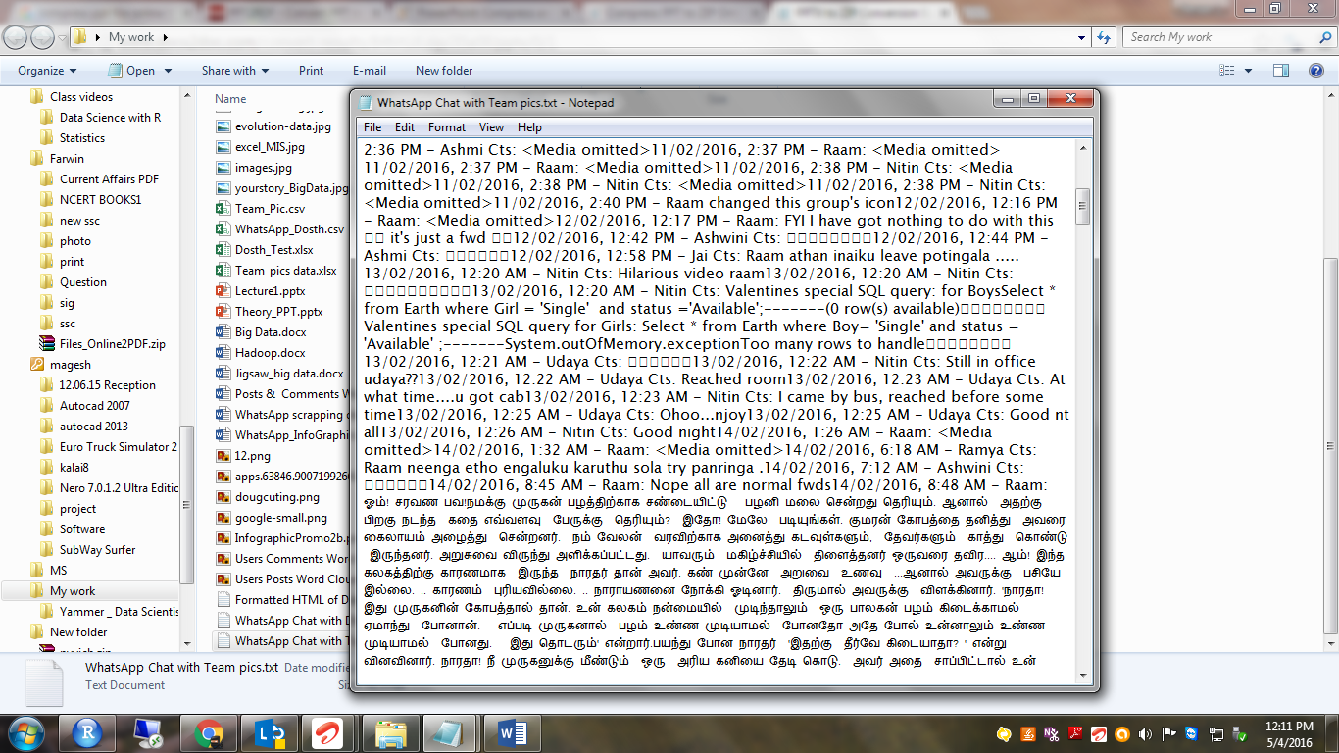

1. I just copy and paste the text in Excel

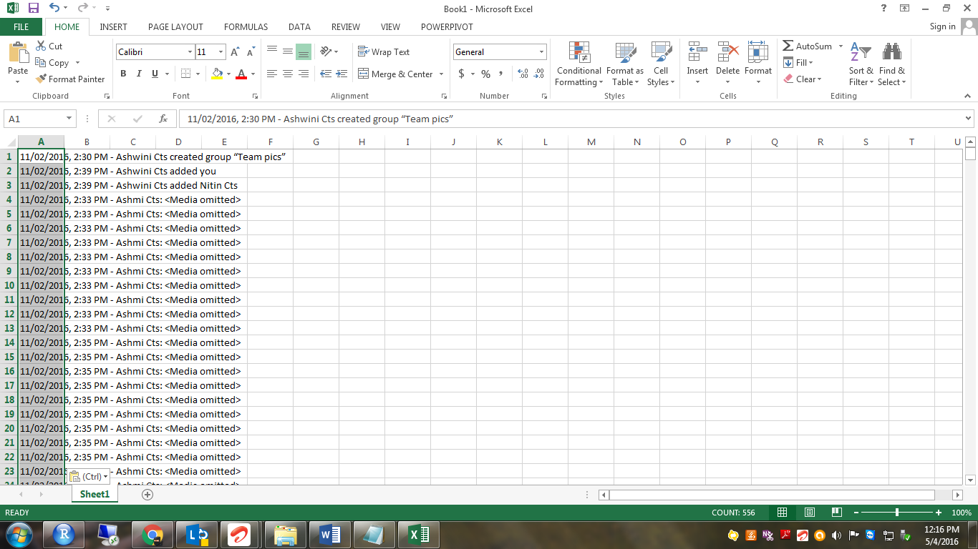

1. Then I just arrage the data’s to fit into my columns like below

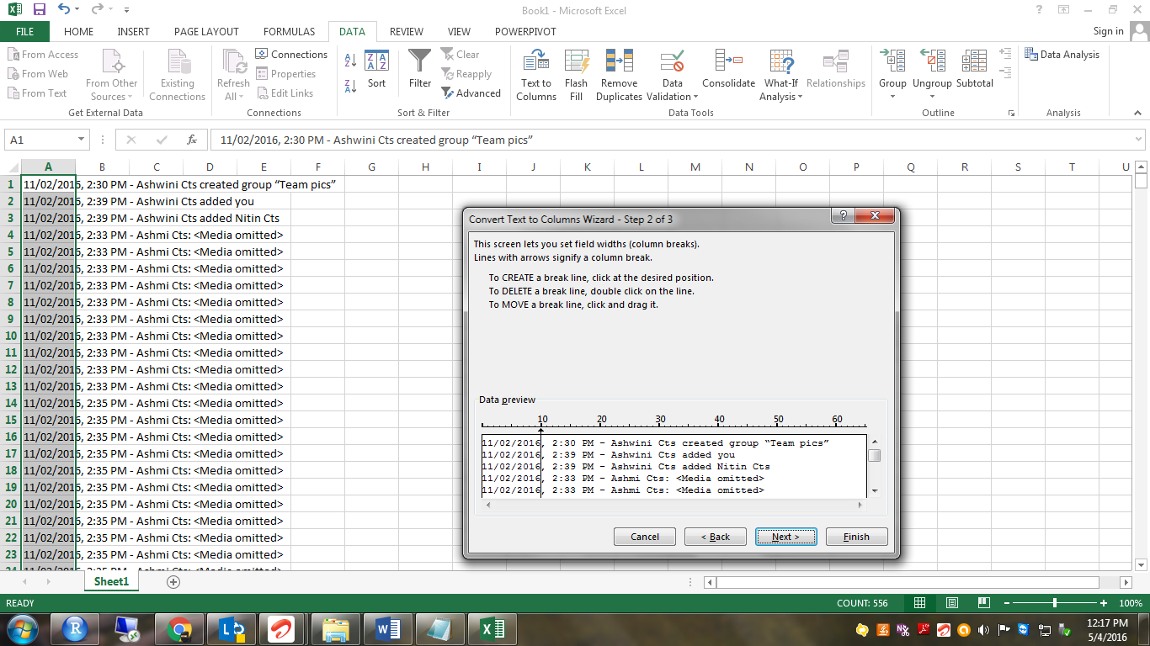

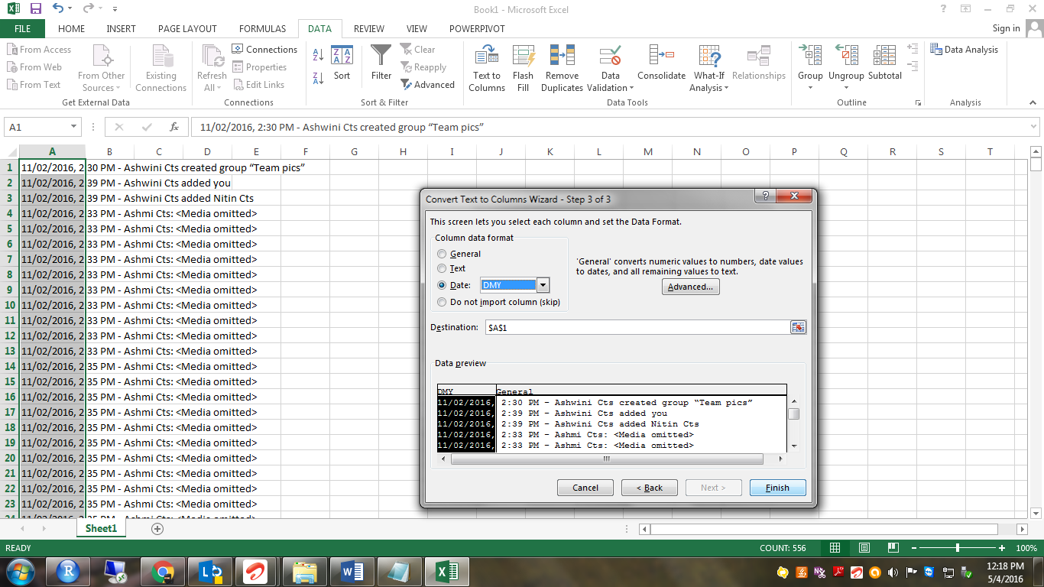

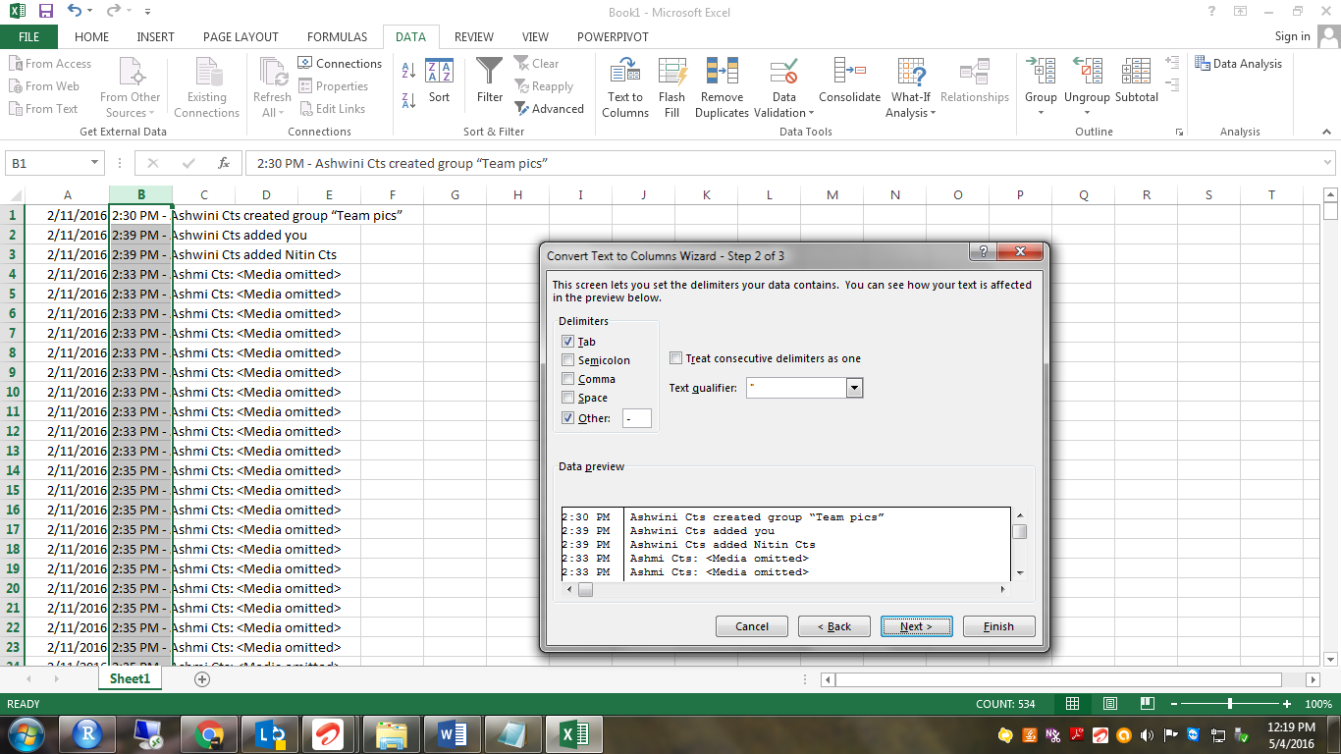

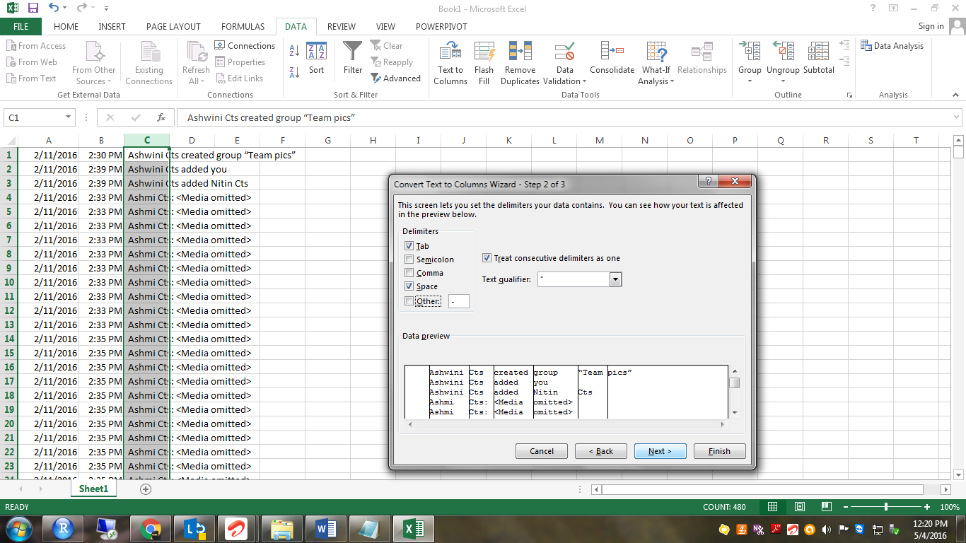

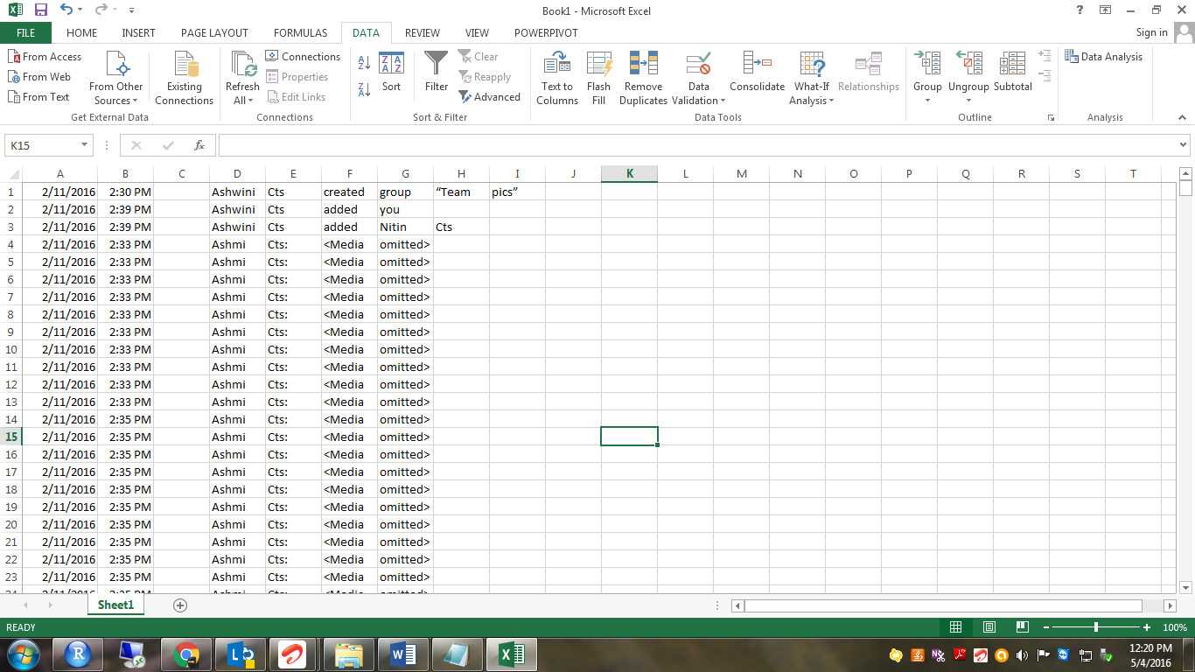

1. I need just Date, time & User name. So I remoevd all other texts.

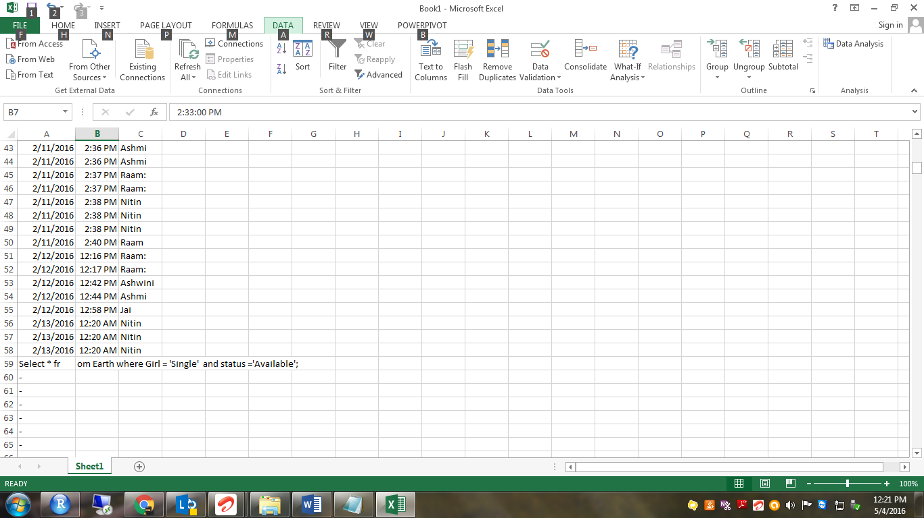

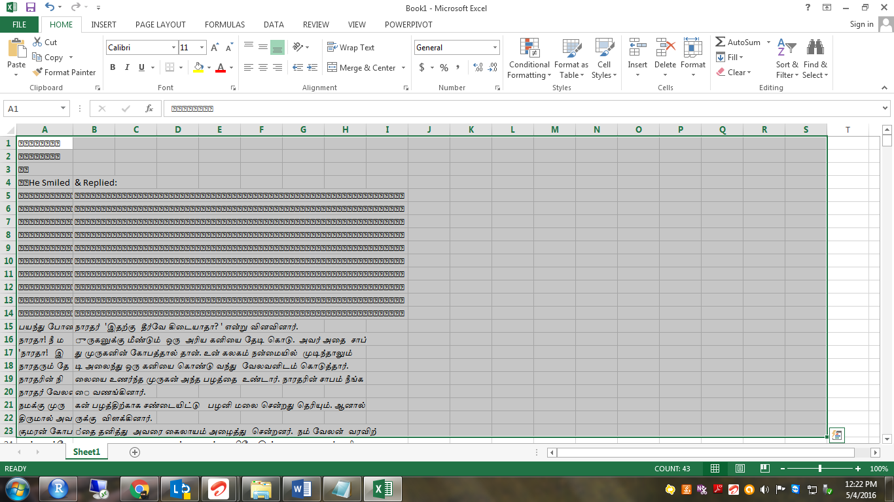

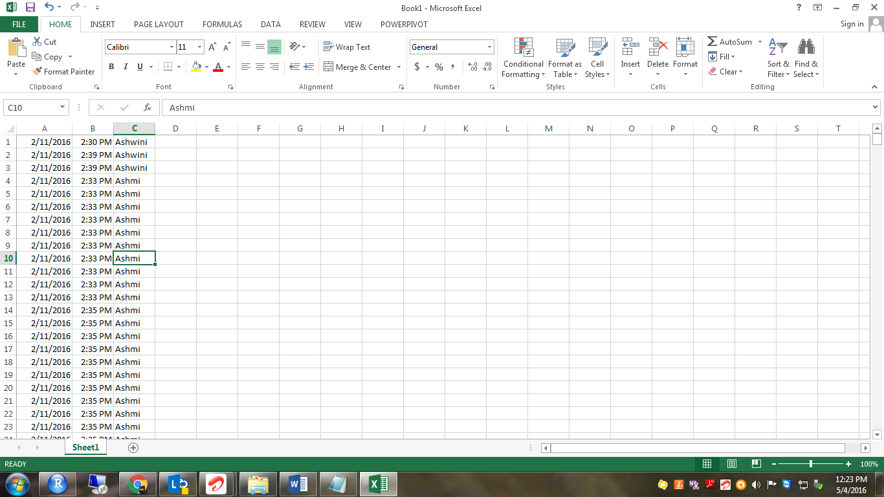

1. So my final Excel file will be look like below and I saved it in CSV format.

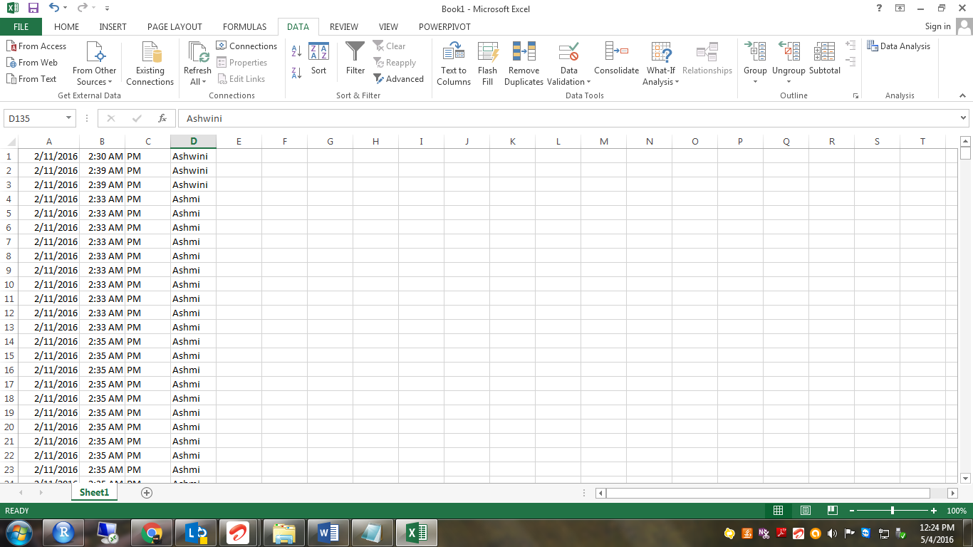

1. Here we starts with RStudio to convert those data into visuals which we can easily understand.

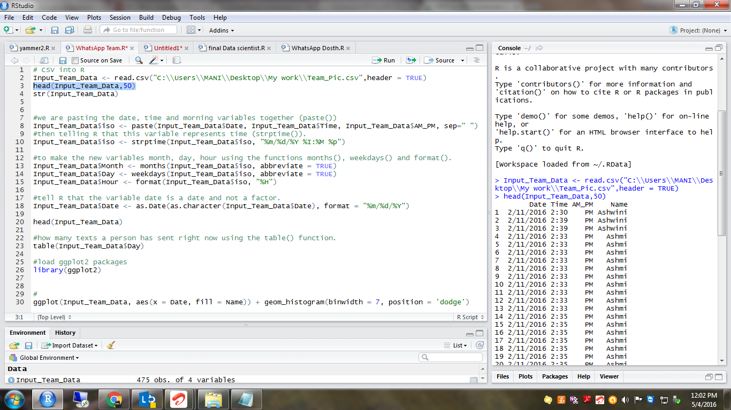

1. First I load my CSV data into R object dataframe.
2. Then I combine date & time to one variable called **iso** for latter user.

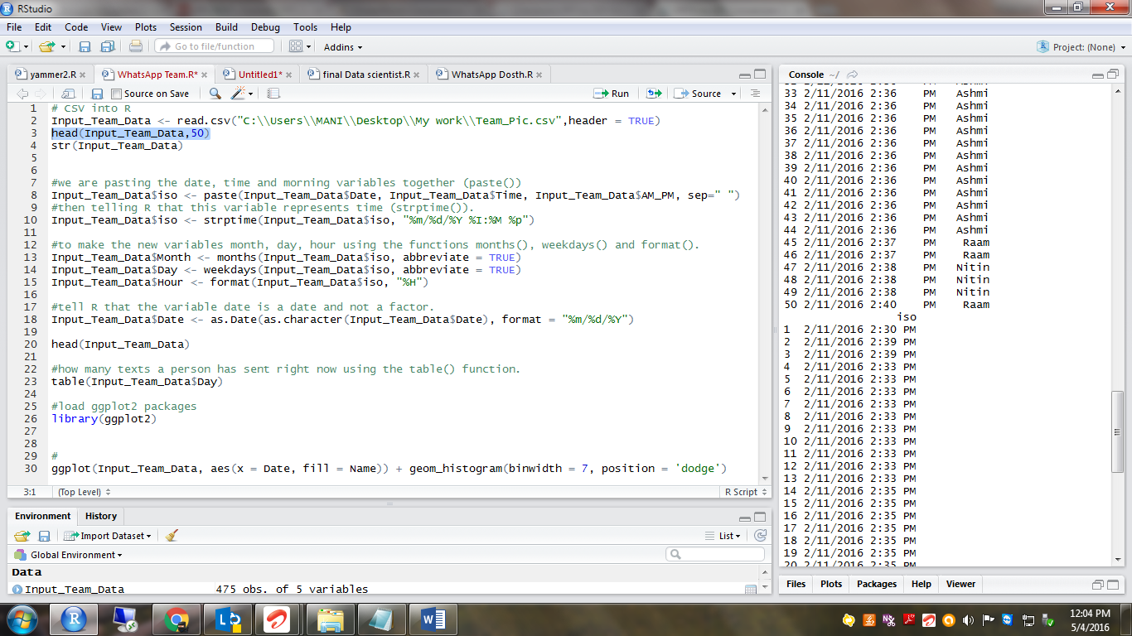

1. Then convert the new variable into date time format.

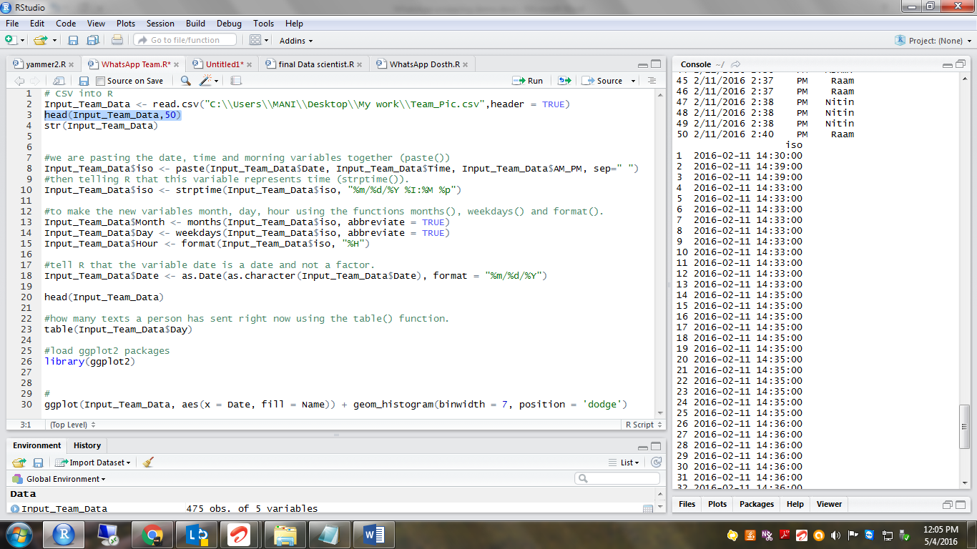

1. Then extract Month, Day & Hour individually from the “**iso**” variable and stored them in new variables(this new variables will be in handy for visual representations ).

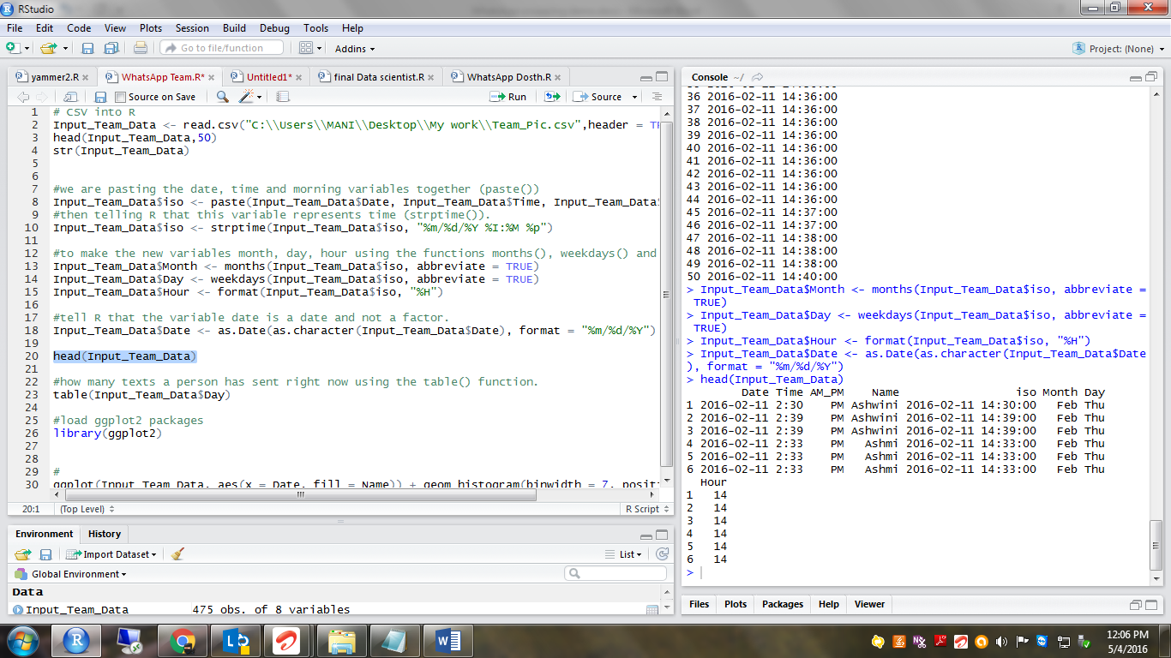

1. I took a frequency distribution of message per each users and message per each day of the week using the table function.

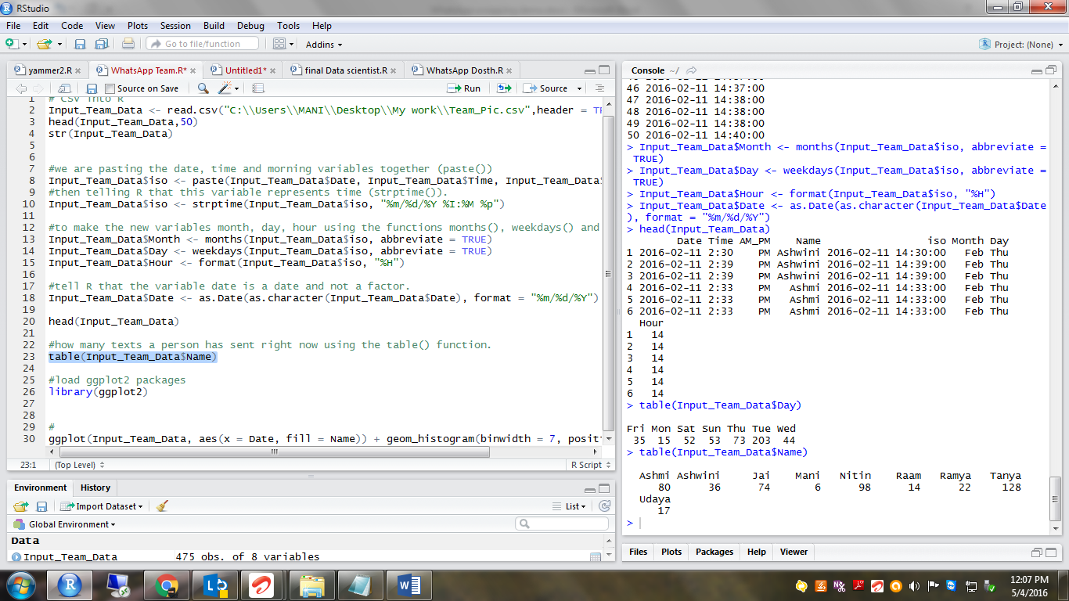

1. Finally by using the **ggplot2** package, below different visual representations are created. They are shows messages sent by each user and messages sent on each hour.

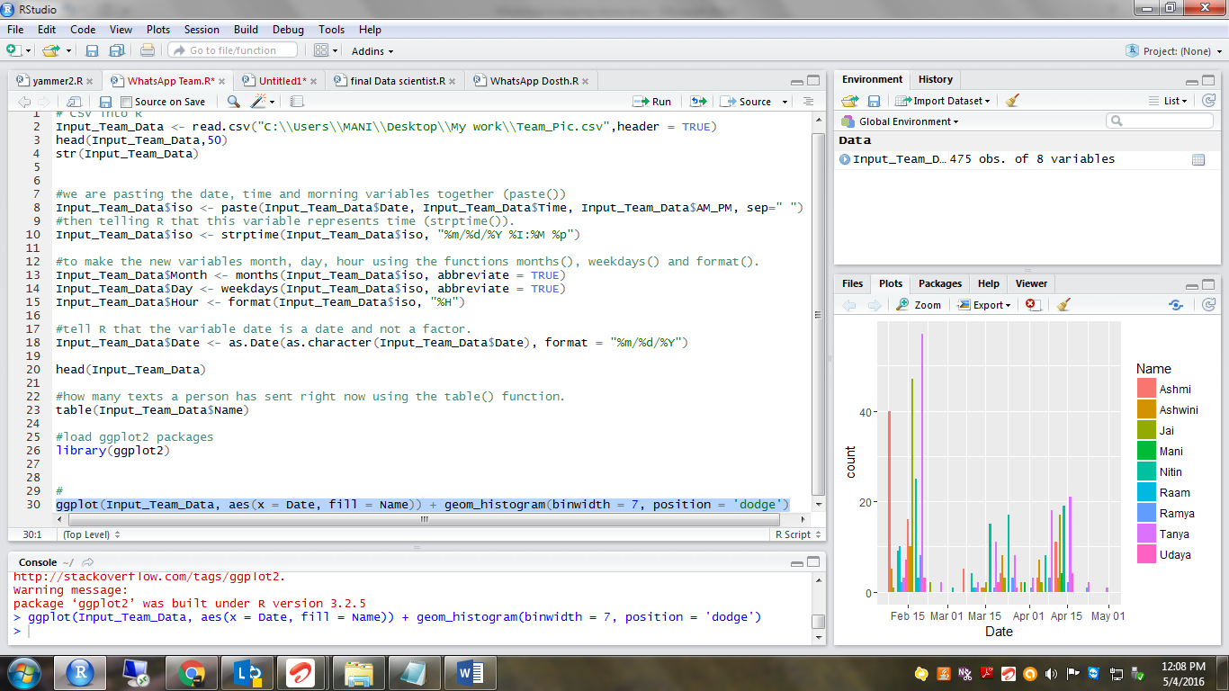

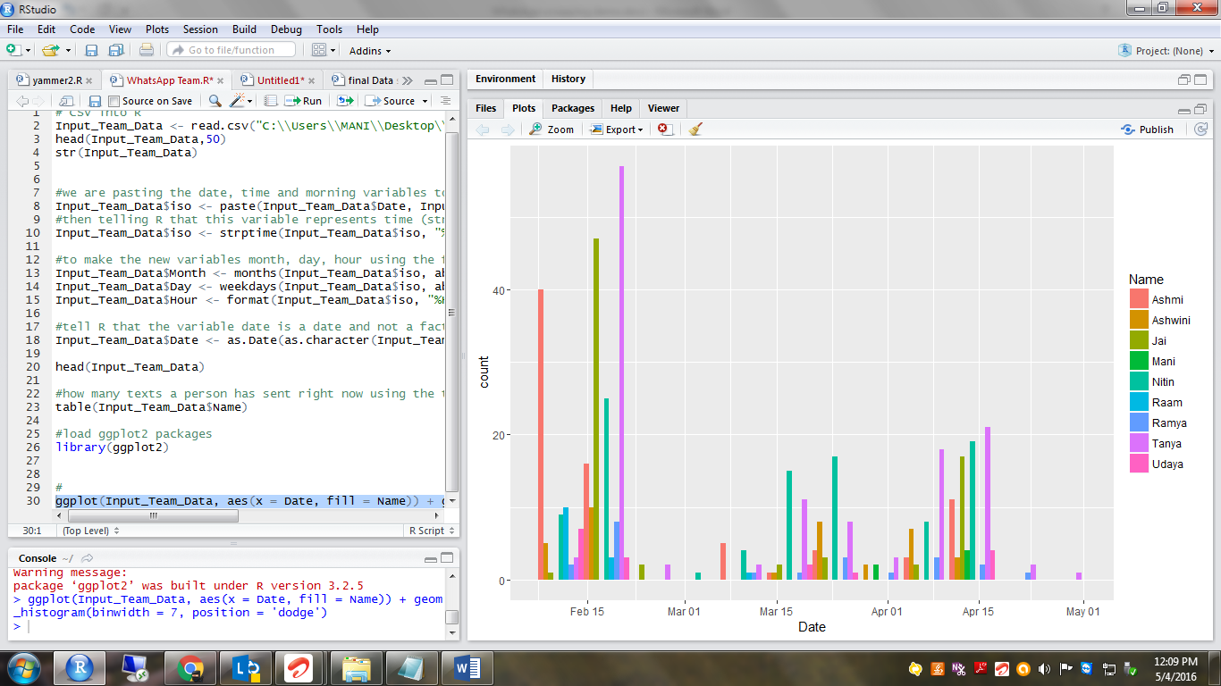

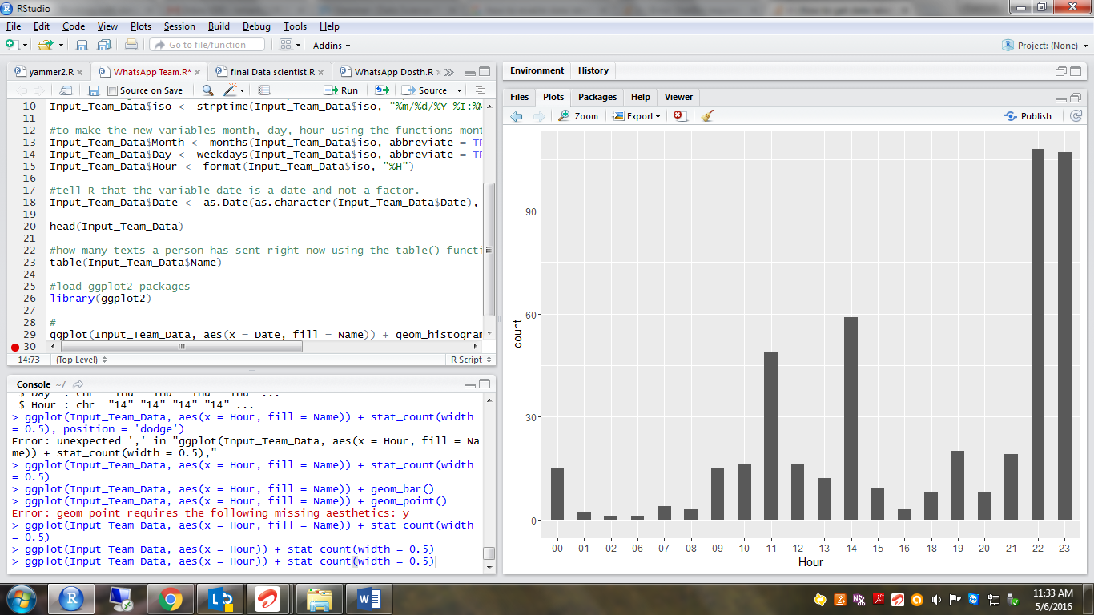

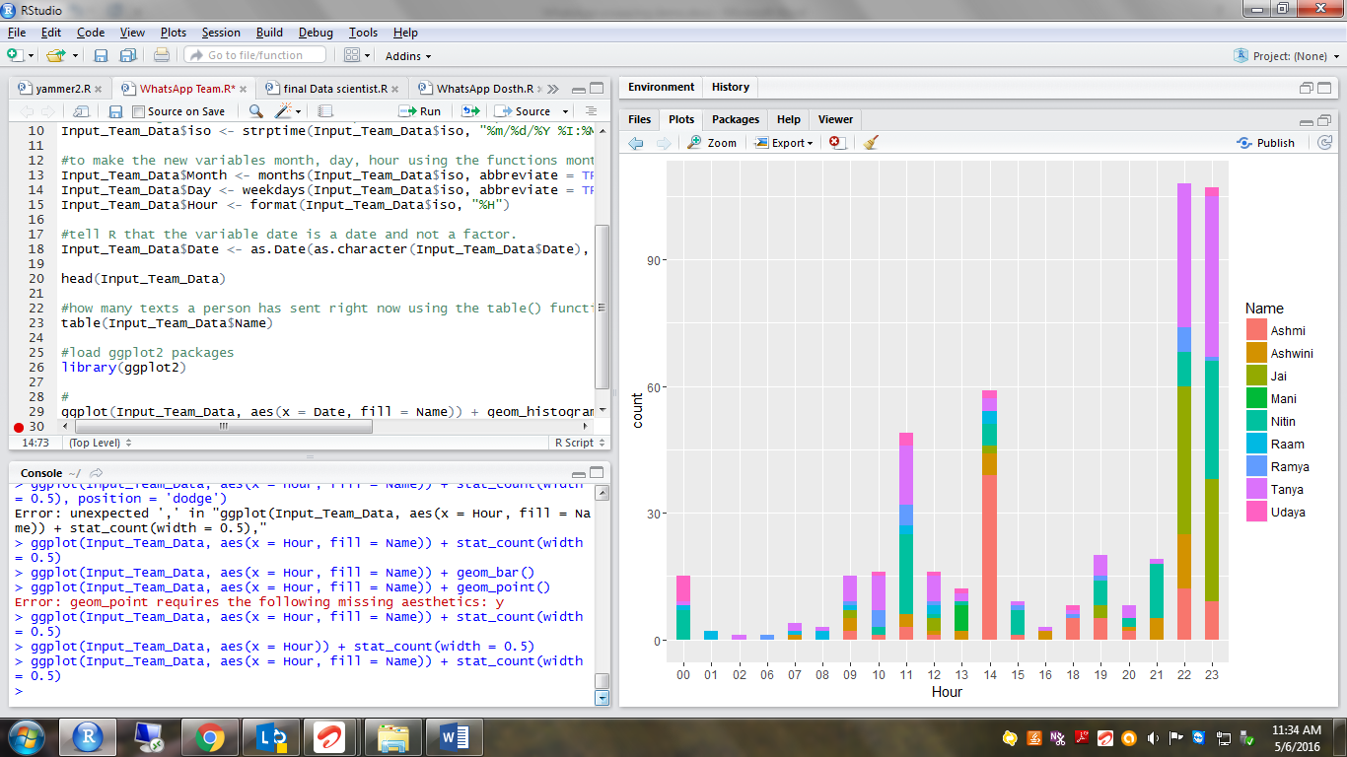

The above pictures shows that my WhatsApp group is more active from 10 PM t0 12 AM. So guys just use technology and don’t let the technology to use you.

Happy Learning………

Manikandan